**ESE PRESCHOOL**

**SILVER LAKES ELEMENTARY 2024-2025 SUGGESTED SUPPLY LIST**

* 2 boxes Zip Snack size Ziploc bags
* 2 boxes Zip Quart size Ziploc bags
* 2 boxes Zip Gallon size Ziploc bags
* 2 boxes of tissues
* 1 pack of Play-Doh (4 pack)
* 10 boxes of baby wipes(can be refill packs)
* 2 pack of dry erase markers (multi-color)
* 4 plastic 3 pronged, 2 pocket folders (solid colors)
* 4 large glue sticks & 4 small glue sticks
* 2 bottles of liquid glue
* 2 bottles of hand sanitizer
* 1 ream of white copy paper
* 1 One inch black binder
* 1 ream multicolor copy paper
* 2 boxes of 8 count LARGE Crayola crayons
* 2 boxes of 24 count small Crayola crayons
* 1 box of skinny Crayola washable markers
* 1 box of broad Crayola washable markers
* 1 plastic Sterilite Pencil box
* 1 box of jumbo pencils
* 1 pair of small Fiskar scissor/blunt
* 1 pkg AA batteries
* 1 pkg AAA batteries
* 1 blanket, 1 small pillow w/pillowcase, 1 crib sheet for mat
* 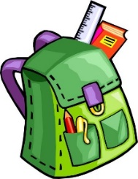2 extra change of clothes (undergarment, shirt, pants, & socks)
* Headphones
* Full-size Backpack & Daily Snack
* 1 spiral notebook-100 sheets

**KINDERGARTEN**

* 1 composition book
* 1 plastic folder
* 1 pack FAT Kindergarten writing pencils
* 3 boxes Crayola 24 count crayons
* 1 box of tissues

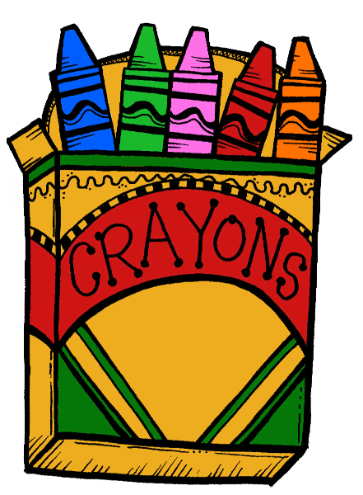

* 2 packs of baby wipes
* 4 LARGE glue sticks
* 1 bottle of hand sanitizer
* 1 four-pack Play-Doh
* 1 Plastic pencil box
* 1 pair of small scissors/blunt point
* 1 set of headphones (no earbuds)
* **Girls:** 1 box THIN Crayola markers
* **Girls:** 1 box quart size Ziploc bags
* **Boys:** 1 box FAT Crayola markers
* **Boys:** 1 box gallon size Ziploc bags

***Please label the headphones and the***

***Pencil box ONLY.***

**1st GRADE**

* 6 large glue sticks
* 1 box of #2 pencils
* 2 boxes of 24 Crayola crayons
* 1 inch View Finder binder w/ pockets
* 1 plastic pencil box
* 3 composition notebooks
* 1 plastic pocket folder w/ prongs
* 2 reams of photocopy paper
* 1 package of baby wipes
* 1 box of tissues
* 1 set of headphones (no earbuds)
* 1 pair of Fiskar scissors w/round edges
* 1 pack of Crayola multi colored pencils
* 1 pack Crayola markers
* 1 box Ziploc quart bags
* 1 pack Expo Dry erase markers (multicolor)
* 1 box Ziploc Gallon bags

**2nd GRADE**

* 1-inch binder with pocket cover
* 4 spiral notebooks
* 2 plastic folders with prongs (I red and 1 blue)
* 2 packs of #2 pencils
* 2 boxes of crayons, (24 count)
* 1 box Crayola markers-regular
* 1 box colored pencils- 12 count
* 1 large zippered pencil pouch or pencil box
* 8 large glue sticks
* 1 pair of scissors
* 1 pack of dry erase markers
* 2 highlighters
* 2 erasers
* 1 headphones/headset (no earbuds)
* 2 bottles of hand sanitizer
* 2 boxes of tissues
* 2 packs of baby wipes
* 1 box of Ziploc gallon size bags
* 1 box sandwich size Ziploc bags
* 1 pack of white copy paper
* 1 pack of color copy paper

**3rd GRADE**

* Backpack
* Wireless computer mouse
* WIRED Headphones
* 5 Composition notebooks
* 5 plastic Duo-tang folders with prongs-red, black, yellow, green and blue
* 1 red pen



* 24 count Colored pencils
* 24 count Crayons
* 8 count Markers
* 4 pink erasers
* 4 LARGE glue sticks
* Pencil pouch
* 2 -12 pack of pencils
* 1 highlighter **3rd** **cont. ↗**

**3rd grade continued**

* Fiskars scissors
* Scotch laminating pouches



* 1 box of tissues
* 1 ream of copy paper
* 1 ream of cardstock

**4th GRADE**

* 1 (1 inch) binder
* 1 dozen #2 pencils-Sharpened (non-mechanical)
* 1 set of headphones
* 1 box of colored markers
* 1 box of colored pencils
* 1 hand sanitizer
* 2 packs of large glue sticks
* 1 pack of colored dry erase markers
* 4 Vinyl Duo-tang folder with pockets and prongs

Red, green, blue and black

* 2 yellow pocket folders
* 1 soft pencil pouch
* 1 pair of student scissors
* 3 plain (1 subject) spiral notebook (wide ruled)
* 1 wireless mouse (optional)
* 2 boxes of tissues
* 1 pack pink erasers
* 1 box of “quart” Ziploc bags
* 1 box of “gallon” Ziploc bags
* 1 pack of post it notes
* 1 pack of baby wipes
* 1 ream of white copy paper
* 2 highlighters

**5th GRADE**

* 2 boxes of #2 pencils (non-mechanical)
* 4 1-subject spiral notebook
* 1 box of (12) colored pencils
* 1 pack of highlighters
* 1 pack of antibacterial wipes
* 2 boxes of tissues
* 1 set of headphones or earbuds
* 1 soft pencil pouch
* 1 box of quart size Ziploc bags
* 1 box of gallon size Ziploc bags
* 1 pair of scissors
* 4 Large glue sticks
* 1 ream of copy paper
* 1 box of 8 markers
* 1 bottle of hand sanitizer
* 5 duo tang pocket folders with prongs
* 2 packs of pencil cap erasers

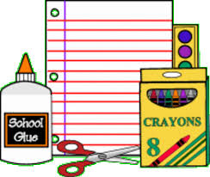

**ESE CLUSTER**

* 1 pack #2 pencils
* 1 pack colored pencils
* 5 large glue sticks
* 1 bottle liquid Elmer’s glue
* 1 pair of safety scissors
* 2 big erasers
* 1 pack dry erase markers (thin)
* 1 pack dry erase markers (regular)
* 1 pack washable markers
* 1 pack highlighters
* 1 plastic Sterilite pencil box
* 3 One-inch black binders (with cover sleeve)
* 1 clipboard (standard size)
* 3 packs binder dividers
* Velcro dots
* 1 pack of plastic sheet protectors
* 4 spiral notebooks (1 subject)
* 2 composition books
* 5 3-prong duo-tang folders (blue, red, yellow, green, orange)
* 1 pack index cards
* 2 reams white copy paper
* 1 ream multicolor copy paper
* 1 set headphones
* 2 boxes snack size Ziplock bags
* 2 boxes quart size Ziplock bags
* 2 boxes gallon size Ziplock bags
* 2 boxes of baby wipes
* 1 bottle hand sanitizer
* 2 liquid antibacterial soap
* 2 boxes of facial tissues
* 1 pack AA batteries
* 1 pack AAA batteries

************************************

THANK YOU IN ADVANCE FOR YOUR DONATIONS TO OUR CLASSROOM. YOUR CHILD’S TEACHER MAY ASK FOR ADDITIONAL SUPPLIES. THESE ARE SUGGESTED SUPPLIES.

**NO ROLLING BACKPACKS**